### Lab 2 Play with Mininet

Name: Eduardo Wang Zheng

E-mail: eduardo@sjtu.edu.cn

1. Experiments
   1. Part 1
      1. Analysis

I simulate the topology in Mininet and set the link bandwidth for (s1,s2) and (s1,s3) as 10Mbps.

* + 1. Evaluation

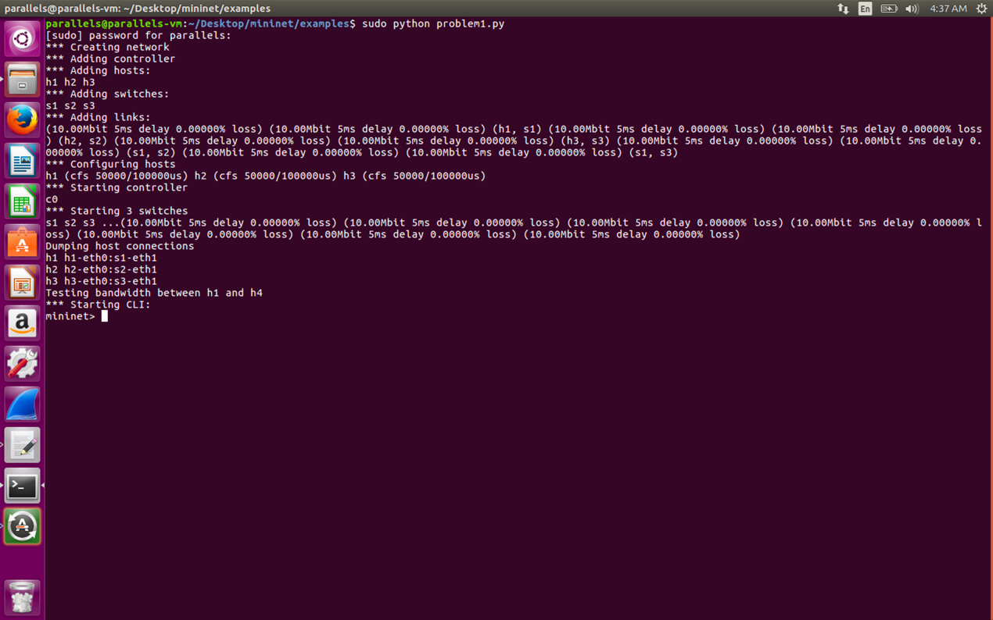

Figure 1 Create the network







Figure 2 Use Iperf to test the TCP throughput between every host pair.

* 1. Part 2
     1. Analysis

I simulate the same topology in Mininet but set the packet loss rate of the link (s1,s2) and (s1,s3) as 5%.

* + 1. Evaluation

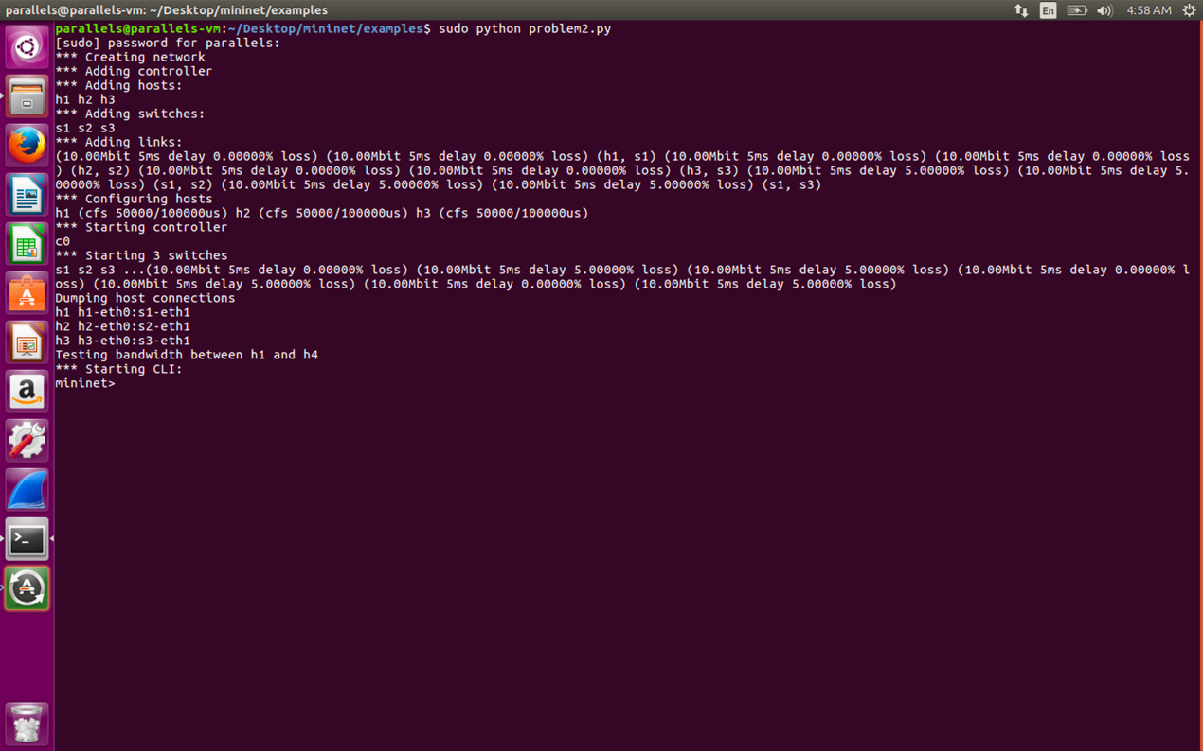

Figure 3 Create the network







Figure 4 Use Iperf to test the TCP throughput between every host pair.

We can see that the TCP throughput between every host pair becomes smaller due to the packet loss.

* 1. Part 3
     1. Analysis

I add another link between s2 and s3 and simulate the new topology in Mininet.

* + 1. Evaluation

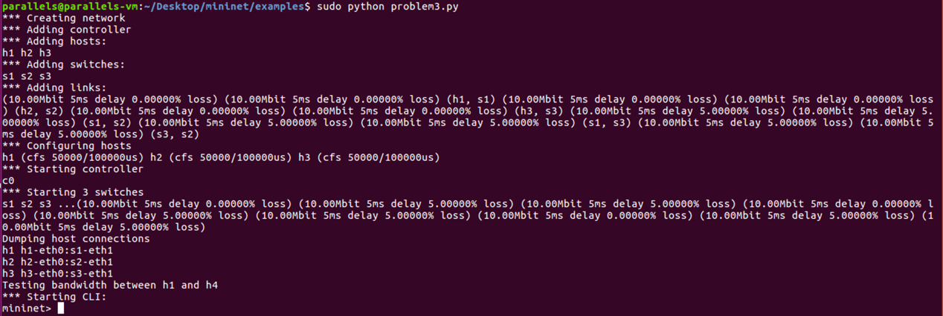

Figure 5 Create the network

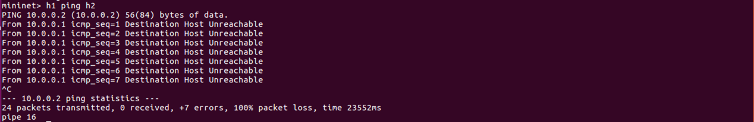

Figure 6 pinging h2 from h1

We can see that no packets can be transmitted from h1 to h2. The packet loss rate is 100%.

To solve the problem, I use **ovs-ofctl** command to add flow rules:



Figure 7 use **ovs-ofctl** command to add flow rules

Now the “dead loop” in the original topology is resolved. We try pinging h2 from h1 again:

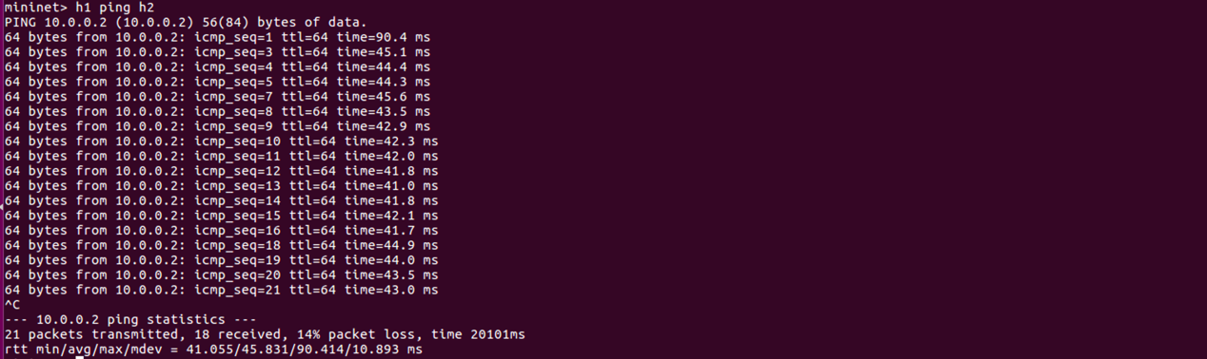

Figure 8 pinging h2 from h1

We can see that packets can be transmitted from h1 to h2 now.